**Project Design Phase-II**

**Data Flow Diagram & User Stories**

|  |  |
| --- | --- |
| Date | **26 Oct 2022** |
| Team ID | **PNT2022TMID49884** |
| Project Name | **Personal Assistance for Seniors Who Are Self Reliant.** |
| Maximum Marks | 4 Marks |

**Dataflow Diagram:**

**Start**

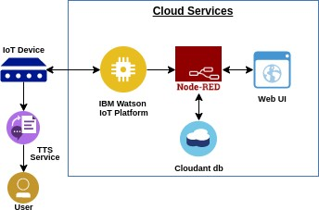•Initialisation

Step 1

•

Data Fed

•

Reamind on the time to take

medication with voice command

Step 3

•

Keep Track of time taken

medicine remains

•

Send SMS or Email to went medicine is needed

**End**

Step 2

Step 4

**Technical Architecture:**

**User Stories**

|  |  |  |  |  |  |  |
| --- | --- | --- | --- | --- | --- | --- |
| **User Type** | **Functional**  **Requirement**  **(Epic)** | **User**  **Story**  **Number** | **User Story / Task** | **Acceptance criteria** | **Priority** | **Release** |
| Customer  (citizen) | Registration | USN-1 | As a user, I can register for the application by confirming OTP and  access manually | I can access my account . | High | Sprint-1 |
| Customer (Doctor) | User Requirements | USN-2 | As a user, I want to monitor patient 24/7. | I can receive confirmation email & click confirm. | High | Sprint-1 |
| Customer  (Care takers) | Confirmations | USN-3 | As a user, I can register and confirm through e-mail OTP. | I can register & access the  dashboard with  Facebook Login. | Low | Sprint-2 |
| Customer  (Elderly people) | Payment options | USN-4 | As a user, I can pay through Cash on Delivery or else with Credit/Debit card. | I can register or pay through login Dashboard. | Medium | Sprint-1 |
| Administrator | Dashboard | USN-5 | As a user, I can log into the application by entering mail and password. | I want to access customer Health and save the Data 24/7. | High | Sprint-1 |